**Systemic Thromboxane Generation and Long-term Survival in Aspirin Users and Non-users**

Running Title: Thromboxane generation and survival

Jeffrey J. Rade, MDa,b,

From the aUniversity of Massachusetts Medical School, Worcester, MA and bJohns Hopkins School of Medicine, Baltimore, MD

Correspondence to: Jeffrey J. Rade, MD, Division of Cardiology, University of Massachusetts Medical School, 55 Lake Avenue North, Worcester, MA 01655. Phone: (774) 441-6310. Fax: (774) 441-6303. Email: jeffrey.rade@umassmed.edu

This study was supported by a grant from American Heart Association (17GRNT3360007 to JJR. The authors had sole control of the design of the study, collection, analysis and dissemination of the data. None of the authors have any disclosures.

Text Word Count:

Key Words: thromboxane, heart failure,

**ABSTRACT**

**IMPORTANCE:** Persistent systemic thromboxane A2 (TXA2) generation in aspirin (ASA) users with cardiovascular disease, predominantly originating from non-platelet sources and stimulated by oxidative stress, predicts adverse clinical outcome and mortality. Knowing the impact of systemic TXA2 generation on long-term outcome in an unselected general population would help identify a wider pool of at-risk individuals and identifying stimuli for its generation would help identify potential therapies.

**OBJECTIVE:** To define variables the determinants of systemic TXA2 generation in a general population and impact on predicts long-term survival irrespective of ASA use.

**DESIGN, SETTING AND PARTICIPANTS:** Prospective observational cohort study of 3044 subjects who participated in examinations 8 and 3 of the Offspring and Omni Cohorts of the Framingham Heart Study.

**EXPOSURES:** Systemic non-renal TXA2 generation at baseline quantified by concentration of stable urine thromboxane B2 metabolites (TXB2-M).

**MAIN OUTCOMES AND MEASURES:**  The main study outcome is long-term survival (up to 10 years). A secondary outcome was time to and category of death.

**RESULTS:**

**CONCLUSION AND RELEVANCE:**

**INTRODUCTION**

Thromboxane A2 (TXA2) is an eicosanoid with potent platelet activating and vasoconstrictor properties generated from the metabolism of arachidonic acid by the actions of cyclooxygenase (COX) and downstream thromboxane synthase enzymes {Patrono, 1990 #2408}. In healthy individuals, TXA2 generation occurs mainly in platelets and is effectively inhibited by aspirin (ASA), which irreversibly inhibits COX-1{Patrono, 2008 #2044}. In contrast, patients with cardiovascular disease generate substantial amounts of TXA2 in non-platelet tissues that is not fully suppressed by standard ASA therapy {Kakouros, 2016 #2543}. Non-platelet TXA2 generation has been shown in several studies to be a novel predictor of adverse cardiovascular outcome and death, though the mechanism by which this occurs is not fully understood {Eikelboom, 2002 #1106}{Eikelboom, 2008 #1747}{Gluckman, 2011 #2036}{Kakouros, 2017 #2835}{McCullough, 2017 #2823}. It is currently not known if non-platelet TXA2 generation in individuals without established cardiovascular disease or if systemic TXA2 generation from platelet and non-platelet sources in non-ASA users also predicts clinical outcome.

This study quantified systemic non-renal TXA2 generation by measuring stable metabolites of thromboxane B2 (TXB2-M)in the banked urine samples of subjects enrolled in the Offspring and Omni cohorts of the Framingham Heart Study and analyzed long-term survival data (up to 12 years). In addition, a comparison of variables associated with systemic TXA2 generation was made between ASA users and non-users.

**METHODS**

Written informed consent was obtained by study participants at each examination and the study protocols were approved by the human subject institutional review boards of the Boston University School of Medicine and the University of Massachusetts Medical School.

The Framingham Heart Study is longitudinal community-based study established in 1948 and comprised of several study cohorts with serial examinations every 4 to 8 years.{Mahmood, 2014 #2843} The study cohort included subjects who attended examination 8 (2005-2008) of the Offspring and examination 3 (2007 to 2008) of the Omni Cohorts. and in whom there was an available banked urine sample obtained at the index examination.

**RESULTS**

**Baseline Characteristics**

Of the3021 Offspring and 298 Omni 1 Cohort subjects who participated, TXB2-M could be measured in 3044 available urine samples banked at the time of the index examination. Of these subjects, 1363 (44.7%) were taking ASA at the time of the examination. Given that standard ASA therapy effectively suppresses platelet but not non-platelet TXA2 generation, median TXB2-M was significantly lower in ASA users compared to non-users (Figure 1). The characteristics of subjects stratified by ASA use and subjects without TXB2-M determination are shown in Table 1. Compared to ASA non-users, ASA users were older with a higher body mass index, more likely to be male and have a higher prevalence of cardiovascular risk factors/established cardiovascular disease with associated medical therapy.

**Determinants of Systemic Thromboxane Generation**

Previous studies have identified age, gender and oxidative stress as major independent determinants of non-platelet TXA2 generation in ASA users with established cardiovascular disease with ASA dose, race, lipid therapy, LVEF and renal function being minor independent determinants.{Kakouros, 2016 #2544}{Eikelboom, 2008 #1747}{McCullough, 2016 #2824;McCullough, 2017 #2825}{McCullough, 2016 #2824}{Szczeklik, 2016 #2823} Multivariable modeling was performed to determine if these same variables were associated with TXA2 generation in an unselected population and if there were differences between ASA users and non-users. Supplement Table 1 shows univariate regression analyses of demographic and laboratory variables available at the time of the index examination. Multivariable modeling revealed age, gender, oxidative stress and renal function were also independently associated with TXA2 generation irrespective of ASA use, as were cigarette use and the inflammatory markers IL-6 and P-selectin (Table 2). ASA dose, diabetes, proteinuria and atrial fibrillation/flutter were independently associated with TXB2-M in ASA users while NSAID use, hypertension oral anticoagulant use and HDL were associated with TXB2-M in non-ASA users.

**Association of Systemic Thromboxane Generation with Long-term Survival**

A total of 710 subjects (23.0%) died during a median observation period for survivors of 12.3 years (IQR, 11.6, 12.9 years) from the index examination. Long-term survival was significantly lower in ASA users compared to non-users (Figure 2A) and was significantly impacted by degree of systemic TXA2 generation irrespective of ASA use (Figures 2B and 2C and Supplement Figure 1). In both groups, systemic TXA2 generation was also associated with mortality risk in all categories of death except stroke (Table 3). Supplement Figure 2 shows the impact of systemic TXA2 generation on mortality in the presence or absence of specific subject characteristics. To better understand the strength of association between systemic TXA2 generation and all-cause mortality, multivariable modeling was performed to adjust for known predictors of mortality in individuals of similar median age (Table 4). Even after adjusting for age and gender (Model 2) or other predictors of death from heart disease, stroke, diabetes and kidney disease (Model 3), systemic TXA2 generation remains significantly associated with all-cause mortality irrespective of ASA use.

|  |  |  |  |  |
| --- | --- | --- | --- | --- |
| **Table 1.** Clinical and laboratory characteristics of subjects at index examination stratified by aspirin use. | | | |  |
| **Characteristic** | **ASA Users**  **(N = 1363)** | **ASA Non-users**  **(N = 1681)** | **P-value** | **Missing**  **(N=278)** |
| Age, mean (SD) | 68 (8) | 64 (9) | <0.0001 |  |
| Female gender, n (%) | 604 (44.3) | 1033 (61.5) | <0.0001 |  |
| Non-white race, n (%) | 84 (6.2) | 124 (7.5) | 0.1635 |  |
| Hispanic ethnicity, n (%) | 34 (2.8) | 58 (3.9) | 0.1416 |  |
| BMI (kg/m2), mean (SD) | 28.8 (5.4) | 28.0 (5.5) | <0.0001 |  |
| eGFR (mL/min/1.73 m2), mean (SD) | 76.0 (16.8) | 80.8 (15.8) | <0.0001 |  |
| Cigarette use, n (%) |  |  | 0.2472 |  |
| Current | 90 (6.6) | 138 (8.2) |  |  |
| Former | 47 (3.5) | 54 (3.2) |  |  |
| Never | 1221 (89.9) | 1489 (88.6) |  |  |
| LVEF (%), mean (SD) | 65.8 (7.4) | 66.5 (6.2) | 0.0103 |  |
| Atrial fibrillation/flutter rhythm on ECG, n (%) | 28 (2.1) | 44 (2.6) | 0.3093 |  |
| Medical history of: |  |  |  |  |
| Hypertension, n (%) | 902 (66.2) | 628 (37.4) | <0.0001 |  |
| Hyperlipidemia, n (%) | 822 (60.4) | 463 (27.6) | <0.0001 |  |
| Diabetes, n (%) | 275 (20.3) | 162 (9.7) | <0.0001 |  |
| Heart failure, n (%) | 39 (2.9) | 29 (1.7) | 0.0350 |  |
| Myocardial infarction, n (%) | 190 (13.9) | 72 (4.3) | <0.0001 |  |
| Atrial fibrillation/flutter, n (%) | 113 (8.3) | 96 (5.7) | 0.0051 |  |
| Cerebrovascular disease, n (%) | 90 (6.6) | 84 (5.0) | 0.0577 |  |
| Peripheral vascular disease, n (%) | 88 (6.5) | 42 (2.5) | <0.0001 |  |
| Coronary revascularization, n (%) | 306 (22.5) | 83 (4.9) | <0.0001 |  |
| PCI, n (%) | 203 (14.9) | 65 (3.9) | <0.0001 |  |
| CABG surgery, n (%) | 155 (11.4) | 26 (1.6) | <0.0001 |  |
| Valvular heart surgery, n (%) | 41 (3.0) | 19 (1.1) | 0.0002 |  |
| COPD, n (%) | 104 (7.8) | 114 (6.9) | 0.3617 |  |
| DVT/PE, n (%) | 21 (1.5) | 39 (2.3) | 0.1241 |  |
| Cancer, n (%) | 489 (35.9) | 497 (29.6) | 0.0002 |  |
| Medication use: |  |  |  |  |
| Aspirin dose >81 mg/d, n (%) | 353 (25.9) |  |  |  |
| NSAID, n (%) | 315 (23.1) | 453 (27.0) | 0.0154 |  |
| Antihypertensive therapy n (%) | 51 (3.7) | 35 (2.1) | 0.0060 |  |
| Beta-blocker, n (%) | 540 (39.6) | 275 (16.4) | <0.0001 |  |
| ACEi/ARB, n (%) | 622 (45.6) | 385 (22.9) | <0.0001 |  |
| Lipid therapy, n (%) | 893 (65.5) | 578 (34.4) | <0.0001 |  |
| Statin, n (%) | 776 (56.9) | 429 (25.5) | <0.0001 |  |
| Non-statin, n (%) | 117 (8.6) | 149 (8.9) | 0.7858 |  |
| Diuretic, n (%) | 423 (31.0) | 323 (19.2) | <0.0001 |  |
| Insulin, n (%) | 38 (2.8) | 11 (0.7) | <0.0001 |  |
| Non-insulin diabetic therapy, n (%) | 179 (13.1) | 103 (6.1) | <0.0001 |  |
| Oral anticoagulant, n (%) | 52 (3.8) | 102 (6.1) | 0.0048 |  |
| Laboratory data: |  |  |  |  |
| Serum creatinine (mg/dL), mean (SD) | 0.95 (0.30) | 0.88 (0.27) | <0.0001 |  |
| Fasting plasma glucose (mg/dL) | 110 (27) | 104 (21) | <0.0001 |  |
| Hemoglobin A1C (%), mean (SD) | 5.8 (0.8) | 5.7 (0.6) | <0.0001 |  |
| Plasma lipid profile: |  |  |  |  |
| Total cholesterol (mg/dL), mean (SD) | 175 (36) | 195 (36) | <0.0001 |  |
| LDL cholesterol (mg/dL), mean (SD) | 97 (30) | 112 (32) | <0.0001 |  |
| HDL (mg/dL), mean (SD) | 55 (17) | 60 (18) | <0.0001 |  |
| Triglyceride (mg/dL), mean (SD) | 119 (75) | 116 (68) | 0.2351 |  |
| Serum CRP (mg/L), mean (SD) | 3.2 (7.4) | 3.4 (7.3) | 0.4580 |  |
| Serum insulin (pmol/L), mean (SD) | 83.2 (65.9) | 70.5 (47.1) | <0.0001 |  |
| Serum MCP (pg/mL), mean (SD) | 383 (140) | 380 (136) | 0.5633 |  |
| Serum IL-6 (pg/mL), mean (SD) | 2.74 (2.94) | 2.51 (2.93) | 0.0395 |  |
| Plasma P-selectin (ng/mL), mean (SD) | 41.2 (13.8) | 41.3 (13.5) | 0.8124 |  |
| Plasma Lp-PLA2 (ng/mL), mean (SD) | 195 (52) | 204 (48) | <0.0001 |  |
| Urine 8-isoPGF2α (pg/mg creatinine), mean (SD) | 1096 (599) | 1149 (663) | 0.0203 |  |
| Urine albumin-creatinine ratio (mg/g), median (IQR) | 61.2 (34.3, 137.8) | 59.2 (34.9, 114.8) | 0.2125 |  |
| Abbreviations: SD, standard deviation; BMI, body mass index; eGFR, estimated glomerular filtration rate; LVEF, left ventricular ejection fraction; ECG, electrocardiogram; PCI, percutaneous coronary intervention; CABG, coronary artery bypass graft; COPD, chronic obstructive pulmonary disease; DVT, deep vein thrombosis; PE, pulmonary embolus; ACEi, angiotensin converting enzyme inhibitor; ARB, angiotensin receptor blocker; LDL, low-density lipoprotein; HDL, high-density lipoprotein; CRP, C-reactive protein; MCP, macrophage chemotactic factor; IL-6, interleukin-6; Lp-PLA2, lipoprotein-associated phospholipase A2; IQR, interquartile range. | | | | |

|  |  |  |  |  |
| --- | --- | --- | --- | --- |
| **Table 2.** Variables independently associated with urine TXB2-M* by multivariable regression analysis. | | | | |
|  | **ASA Users**  (N=1363) | | **ASA Non-users**  (N=1681) | |
| **Variable** | **Standardized Regression Coefficient** | **P-value** | **Standardized Regression Coefficient** | **P-value** |
| eGFR (per mL/min/1.73m2) | 0.234936 | <0.0001 | 0.199774 | <0.0001 |
| Age (per year) | 0.179731 | <0.0001 | 0.178413 | <0.0001 |
| Female gender (versus male) | 0.139340 | <0.0001 | 0.139287 | <0.0001 |
| Cigarette use (versus never) |  |  |  |  |
| Current | 0.125323 | <0.0001 | 0.046271 | 0.0542 |
| Former |  |  | 0.061389 | 0.0084 |
| Urine 8-isoPGF2α (per pg/mg creatinine) | 0.068704 | 0.0114 | 0.096819 | <0.0001 |
| IL-6 (per pg/mL) | 0.066116 | 0.0128 | 0.089145 | 0.0003 |
| P-selectin (per pg/mL) | 0.063753 | 0.0160 | 0.064814 | 0.0058 |
| ASA dose (>81versus ≤81mg/day) | 0.158261 | <0.0001 |  |  |
| Urine albumin-creatinine ratio (per ln mg/g) | 0.106786 | 0.0002 |  |  |
| Diabetes (versus none) | 0.097258 | 0.0003 |  |  |
| Lipid therapy (versus none) | -0.062817 | 0.0126 |  |  |
| Atrial fibrillation/flutter (versus never) | 0.054034 | 0.0277 |  |  |
| NSAID use (versus none) |  |  | -0.143680 | <0.0001 |
| Oral anticoagulant use (versus none) |  |  | 0.121710 | <0.0001 |
| HDL (per mg/dL) |  |  | -0.107252 | <0.0001 |
| Hypertension (versus none) |  |  | 0.075848 | 0.0021 |
| COPD (versus none) |  |  | 0.048632 | 0.0399 |
| *Ln-transformed.  Abbreviations: eGFR, estimated glomerular filtration rate; IL-6, interleukin-6; ASA, aspirin; NSAID, non-steroidal anti-inflammatory drug; HDL, high density lipoprotein; COPD, chronic obstructive pulmonary disease. | | | | |

|  |  |  |  |  |  |  |  |  |  |  |  |  |  |
| --- | --- | --- | --- | --- | --- | --- | --- | --- | --- | --- | --- | --- | --- |
| **Table 3.** Association of TXB2-M on relative mortality rate by cause of death. | | | | | | | | | | | | | |
| **Cause of Death** | **ASA User (N=1363)** | | | | | **ASA Non-user (N=1680)** | | | | | **All (N=3043)** | | |
|  | **N (%)** | **HR\*** | **P-value** | **HR#** | **P-value** | **N (%)** | **HR\*** | **P-value** | **HR#** | **P-value** | **N (%)** | **HR\*** | **P-value** |
| Any | 389 (28.5) | 1.470 | <0.0001 | 1.743 | <0.0001 | 312 (18.6) | 1.628 | <0.0001 | 2.302 | <0.0001 | 701 (23.0) | 2.137 | <0.0001 |
| CVD | 88 (6.5) | 1.351 | 0.0570 | 1.929 | 0.0030 | 45 (2.7) | 2.192 | 0.0002 | 4.245 | <0.0001 | 133 (4.4) | 3.090 | <0.0001 |
| Stroke | 22 (1.6) | 1.365 | 0.3254 | 1.344 | 0.4903 | 7 (0.4) | 1.081 | 0.8732 | 1.396 | 0.6903 | 29 (1.0) | 1.869 | 0.0926 |
| Cancer | 113 (8.3) | 1.298 | 0.0638 | 1.581 | 0.0168 | 117 (7.0) | 1.429 | 0.0040 | 2.174 | <0.0001 | 230 (7.6) | 1.876 | <0.0001 |
| Other | 136 (10.0) | 1.577 | 0.0002 | 1.710 | 0.0024 | 125 (7.4) | 1.707 | <0.0001 | 2.137 | <0.0001 | 261 (8.6) | 1.991 | <0.0001 |
| Unknown | 30 (2.2) | 2.128 | 0.0009 | 2.551 | 0.0188 | 18 (1.1) | 1.594 | 0.1454 | 1323 | 0.5948 | 48 (1.6) | 2.337 | 0.0034 |
| Abbreviations: HR, hazard ratio; CVD, cardiovascular disease.  *Ln pg/mg creatinine.  #Quartiles 3-4 versus 1-2 for ASA users and quartile 4 versus 1-3 for ASA users. | | | | | | | | | | | | | |

|  |  |  |  |  |  |  |  |  |  |
| --- | --- | --- | --- | --- | --- | --- | --- | --- | --- |
| **Table 4.** Association of TXB2-M* with all-cause mortality when adjusted for relevant risk factors predictive of survival. | | | | | | | | | |
| **Model** | **ASA User (N=1363)** | | | **ASA Non-user (N=1680)** | | | **All (N=3043)** | | |
|  | **OR** | **95% CI** | **P-value** | **OR** | **95% CI** | **P-value** | **OR** | **95% CI** | **P-value** |
| Model 1# | 1.917 | 1.508, 2.438 | <0.0001 | 2.464 | 1.899, 3.196 | <0.0001 | 2.366 | 1.992, 2.810 | <0.0001 |
| Model 2† | 1.771 | 1.349, 2.326 | <0.0001 | 1.866 | 1.379, 2.525 | <0.0001 | 1.789 | 1.469, 2.179 | <0.0001 |
| Model 3§ | 1.613 | 1.188, 2.190 | 0.0022 | 1.989 | 1.425, 2.777 | <0.0001 | 1.729 | 1.389, 2.152 | <0.0001 |
| Abbreviations: OR, odds ratio; CI, confidence interval; LVEF, left ventricular ejection fraction, eGFR, estimated glomerular filtration rate.  *Quartiles 3-4 versus 1-2 for ASA users and quartile 4 versus 1-3 for non-ASA users.  #Unadjusted  †Adjusted for age and gender.  §Adjusted for age, gender, mean arterial blood pressure, atrial fibrillation, LVEF, hemoglobin A1C, and eGFR. (N =1290 for ASA and N=1518 for non-ASA groups.) | | | | | | | | | |

Figure Legends

Figure 1

Figure 2

**Figure 1.**

Figure 2A

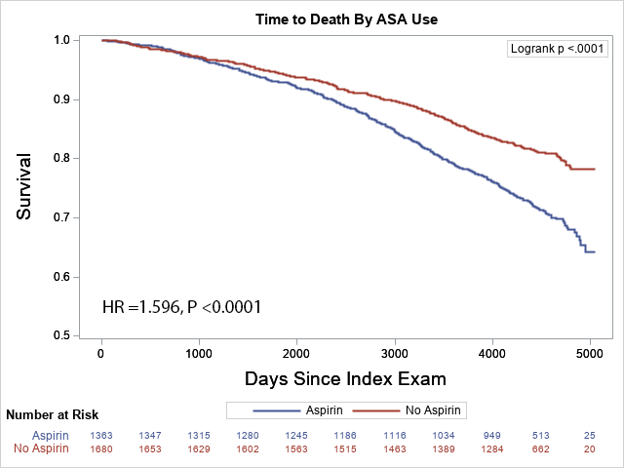

Figure 2B

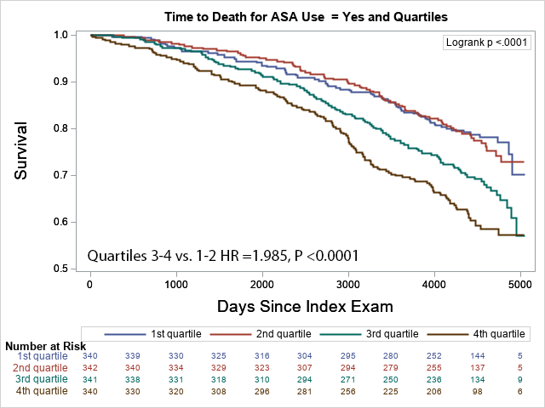

Figure 2C

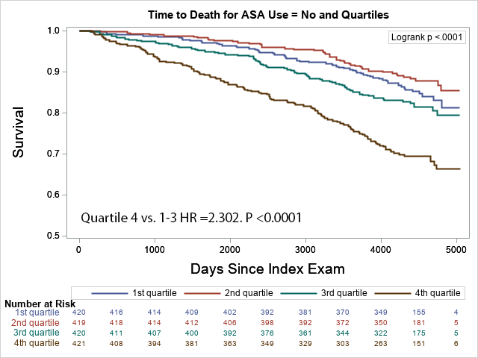

|  |  |  |  |  |
| --- | --- | --- | --- | --- |
| **Supplement Table 1.** Univariate linear regression analyses of the association of variables with urineTXB2-M in aspirin users and non-users. | | | | |
|  | **ASA Users**  (N=1363) | | **ASA Non-users**  (N=1681) | |
| **Variable** | **Standardized Regression Coefficient** | **P-value** | **Standardized Regression Coefficient** | **P-value** |
| Age (per year) | 0.084661 | 0.0016 | 0.152928 | <0.0001 |
| Female gender (versus male) | 0.143685 | <0.0001 | 0.083353 | 0.0006 |
| Non-white race (versus white) | -0.032402 | 0.2301 | 0.056623 | 0.0331 |
| Hispanic ethnicity (versus non-Hispanic) | 0.123911 | <0.0001 | 0.025428 | 0.3244 |
| BMI (per kg/m2) | 0.025472 | 0.3449 | 0.045630 | 0.0617 |
| eGFR (per mL/min/1.73 m2) | 0.127245 | <0.0001 | 0.057184 | 0.0359 |
| Cigarette use (versus never) |  | <0.0001 |  | <0.0001 |
| Current | 0.142412 | <0.0001 | 0.085403 | 0.0005 |
| Former | 0.030349 | 0.2558 | 0.075534 | 0.0019 |
| LVEF (per %) | -0.029155 | 0.3004 | -0.023034 | 0.3670 |
| Atrial fibrillation/flutter rhythm on ECG | 0.054589 | 0.0423 | 0.150148 | <0.0001 |
| Medical history (versus no history): |  |  |  |  |
| Hypertension | -0.010847 | 0.6869 | 0.135535 | <0.0001 |
| Hyperlipidemia | -0.064651 | 0.0163 | 0.035628 | 0.1444 |
| Diabetes | 0.111355 | <0.0001 | 0.083815 | 0.0006 |
| Heart failure | 0.027441 | 0.3080 | 0.057835 | 0.0177 |
| Myocardial infarction | 0.003155 | 0.9074 | 0.088702 | 0.0003 |
| Atrial fibrillation/flutter | 0.066042 | 0.0142 | 0.141437 | <0.0001 |
| Cerebrovascular disease | 0.052967 | 0.0488 | 0.096793 | <0.0001 |
| Peripheral vascular disease | 0.047153 | 0.0813 | 0.002112 | 0.9310 |
| Coronary revascularization | 0.004971 | 0.8576 | 0.067661 | 0.0055 |
| PCI | -0.016742 | 0.5414 | 0.058074 | 0.0173 |
| CABG surgery | 0.017313 | 0.5242 | 0.047353 | 0.0522 |
| Valvular heart surgery | -0.015799 | 0.5569 | 0.039312 | 0.1071 |
| COPD | 0.043989 | 0.1046 | 0.083952 | 0.0006 |
| DVT/PE | 0.009475 | 0.7246 | 0.015881 | 0.5152 |
| Cancer | -0.013559 | 0.6143 | 0.041981 | 0.0853 |
| Medications use (versus none): |  |  |  |  |
| ASA dose (> 81 mg/d versus ≤81 mg/d) | 0.129469 | <0.0001 |  |  |
| NSAID | -0.004733 | 0.8603 | -0.140060 | <0.0001 |
| Antihypertensive use | -0.004105 | 0.8788 | 0.006897 | 0.7775 |
| Beta-blocker | 0.004583 | 0.8657 | 0.118753 | <0.0001 |
| ACEi/ARB | -0.016767 | 0.5339 | 0.047259 | 0.0527 |
| Lipid therapy (versus none) | -0.062567 | 0.0200 | 0.004903 | 0.8408 |
| Statin | -0.051530 | 0.0556 | 0.039598 | 0.1046 |
| Non-statin | -0.015134 | 0.5737 | -0.052546 | 0.0312 |
| Diuretic | -0.010140 | 0.7061 | 0.079397 | 0.0011 |
| Insulin | 0.023885 | 0.3744 | 0.003911 | 0.8727 |
| Non-insulin diabetic therapy | 0.080585 | 0.0028 | 0.069487 | 0.0044 |
| Oral anticoagulant | 0.040608 | 0.1315 | 0.188710 | <0.0001 |
| Laboratory data: |  |  |  |  |
| Serum creatinine (per mg/dL) | -0.171747 | <0.0001 | -0.129675 | <0.0001 |
| Fasting plasma glucose (per mg/dL) | 0.106507 | <0.0001 | 0.081017 | 0.0009 |
| Hemoglobin A1C (per %) | 0.106453 | <0.0001 | 0.118336 | <0.0001 |
| Plasma lipid profile: |  |  |  |  |
| Total cholesterol (per mg/dL) | -0.006613 | 0.8072 | -0.072443 | 0.0030 |
| LDL cholesterol (per mg/dL) | -0.038648 | 0.1525 | -0.070515 | 0.0039 |
| HDL cholesterol (per mg/dL) | -0.012190 | 0.6524 | -0.082174 | 0.0008 |
| Triglycerides (per mg/dL) | 0.075001 | 0.0053 | 0.085082 | 0.0005 |
| Serum CRP (per mg/L) | 0.068296 | 0.0114 | 0.101375 | <0.0001 |
| Serum insulin (per pmol/L) | 0.067949 | 0.0119 | 0.114534 | <0.0001 |
| Serum MCP-1 (per pg/mL) | 0.048542 | 0.0777 | 0.045726 | 0.0670 |
| Serum IL-6 (per pg/mL) | 0.113729 | <0.0001 | 0.159307 | <0.0001 |
| Plasma P-selectin (per pg/mL) | 0.099453 | 0.0002 | 0.098264 | <0.0001 |
| Plasma Lp-PLA2 (per ng/mL) | 0.010924 | 0.6873 | 0.017394 | 0.4816 |
| Urine 8-isoPGF2α (per pg/mg creatinine) | 0.176048 | <0.0001 | 0.190122 | <0.0001 |
| Urine albumin-creatinine ratio (per ln mg/g) | 0.154432 | <0.0001 | 0.163020 | <0.0001 |
| Abbreviations: SD, standard deviation; BMI, body mass index; LVEF, left ventricular ejection fraction; ECG, electrocardiogram; PCI, percutaneous coronary intervention; CABG, coronary artery bypass graft; COPD, chronic obstructive pulmonary disease; DVT, deep vein thrombosis; PE, pulmonary embolus; ACEi, angiotensin converting enzyme inhibitor; ARB, angiotensin receptor blocker; LDL, low-density lipoprotein; HDL, high-density lipoprotein; CRP, C-reactive protein; MCP, macrophage chemotactic factor; IL-6, interleukin-6; Lp-PLA2, lipoprotein-associated phospholipase A2; IQR, interquartile range. | | | | |

**Supplement Figure 1A**

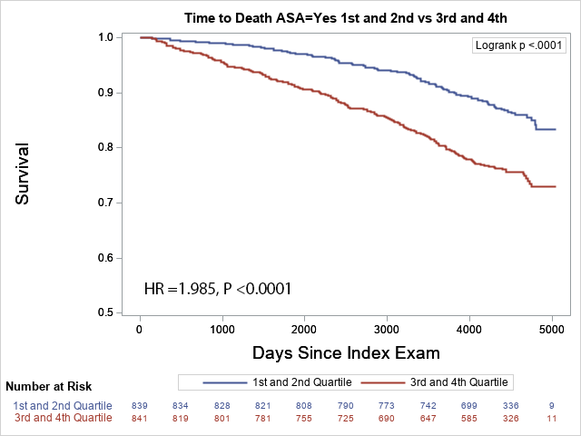

**Supplement Figure 1B**

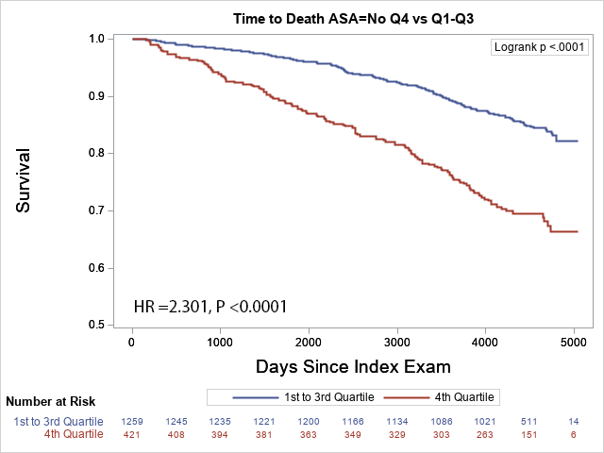

Figure 3A

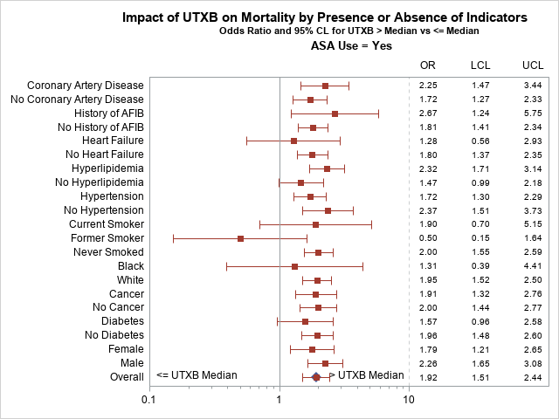

Figure 3B

